**Toledo Lighthouse Waterfront Festival**

**July 7th & 8th Maumee Bay State Park**

***Free Parking……***

***Toledolighthouse.org***

**Festival on the shores of**

* **Boat Rides around and in lighthouse weather permitting**
* **Nautical Arts & Crafts**
* **Beachboys Concert Sat. 7pm**
* **Island Music**
* **American Legion Band**
* **Eddie Boggs Band**
* **Steel Drums**
* **Sand Castles**
* **Food – Fish, Brats etc.**

***TOLEDO LIGHTHOUSE***

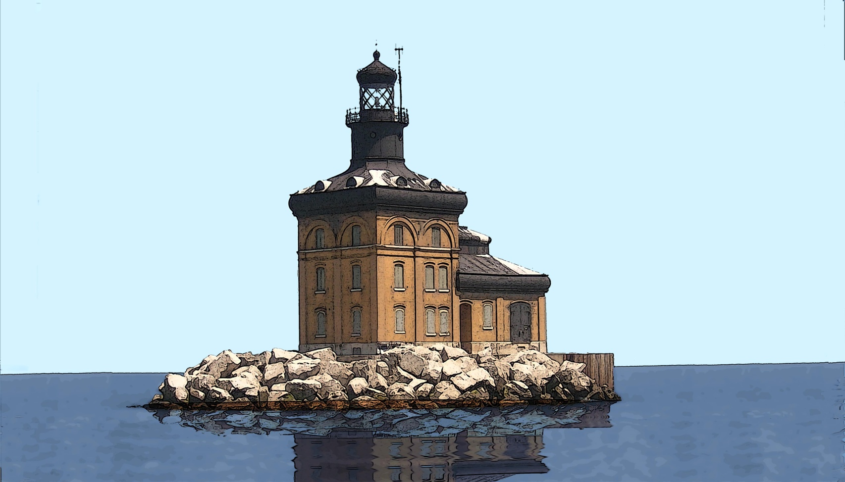

**Lake Erie & Maumee Bay**

* **Fresnel Lens at the Lodge**
* **Huge Silent Auction**
* **Toft’s Ice Cream**
* **Lighthouse Photo Contest**
* **Childrens Activities**

**BP Huskey Eggleston Meinert Pavley**

**Maumee Bay Resort** **Andersons** **Huntington**  **Genoa Bank Key Bank** **5th 3rd Ntnl Bank of Oak Harbor** **Bath Fitter**

**Toledo Blade** **Martin &Martin Ins Window Pro** **Pete McDonald State Farm**

Jeanine Perry Sun Credit Union Key Bank

**Toledolighthouse.org**

**For additional information: General 419-691-3788,** [**sandylakeerie@aol.com**](mailto:sandylakeerie@aol.com)

**Arts & Crafts Peggy Welsh 419-691-3273** [**welsh4348@aol.com**](mailto:welsh4348@aol.com)

**Photo Contest Janet Gladieux,** [**jbglad2425@yahoo.com**](mailto:jbglad2425@yahoo.com) **419-693-1877**

**Silent Auction, Marsha Clere 419-691-4141 & Pat Price 419-693-1778**

**Volunteers Eleaine Klewer 419-836-7919**

**Vote for New Toledo Lighthouse Windows at:** [**http://www.jeld-wen.com/lighthouse**](http://www.jeld-wen.com/lighthouse)

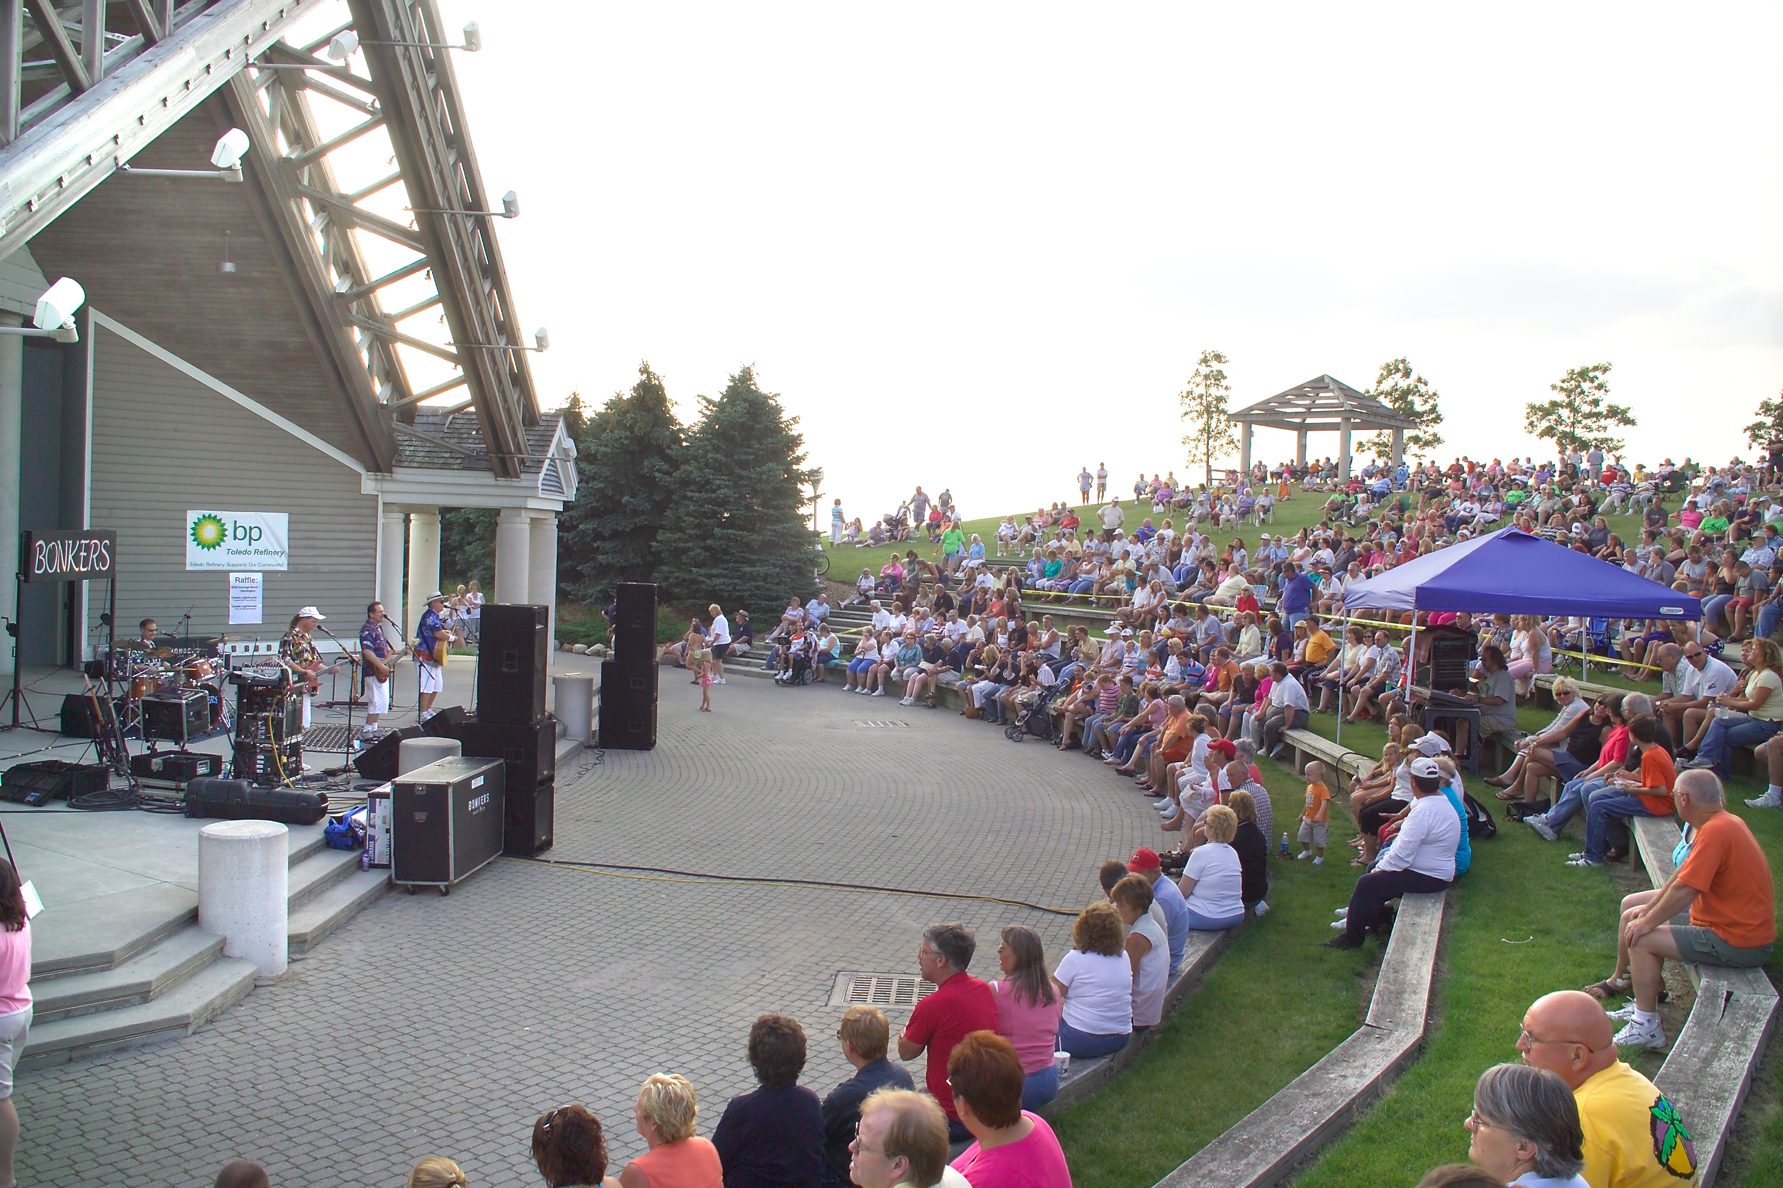

**Toledo Lighthouse Festival Saturday 10 -8 Sunday 10 – 5**

**Nautical Arts & Crafts, Sand Castle Contest, Fest Foods…**

**Huge Silent Auction ends Sunday at 4**

**American Legion Band, Toledo School of the Arts Steel Drums & more**

**BEACHBOY’s TRIBUTE CONCERT by Randy & Reef Sharks SAT. 7 pm**